SANJEEVPRASSANTH. N 241901101
WINDOWS FUNDAMENTALS 1
Expt:1
Aim:
To learn the basic concepts of the Windows operating system, including its interface, file system, security features, system tools, networking, user account management, and advanced Windows administration using the TryHackMe Windows Fundamentals 1.

Procedure:
Windows Fundamentals 1:
- Logged in to the TryHackMe platform and opened the Windows Fundamentals 1 room.
- Learned about the Windows desktop environment, Start Menu, Taskbar, and Settings.
- Explored File Explorer and understood file/folder navigation.
- Studied important system folders such as Desktop, Documents, and Downloads.
- Learned about Control Panel and basic Windows settings.
- Completed the given tasks and answered the questions.

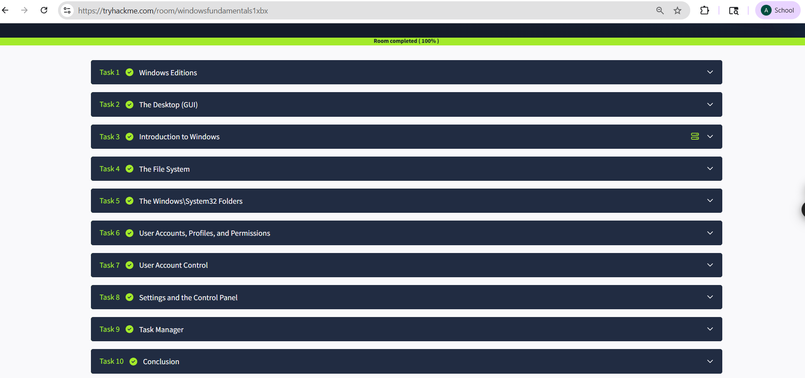

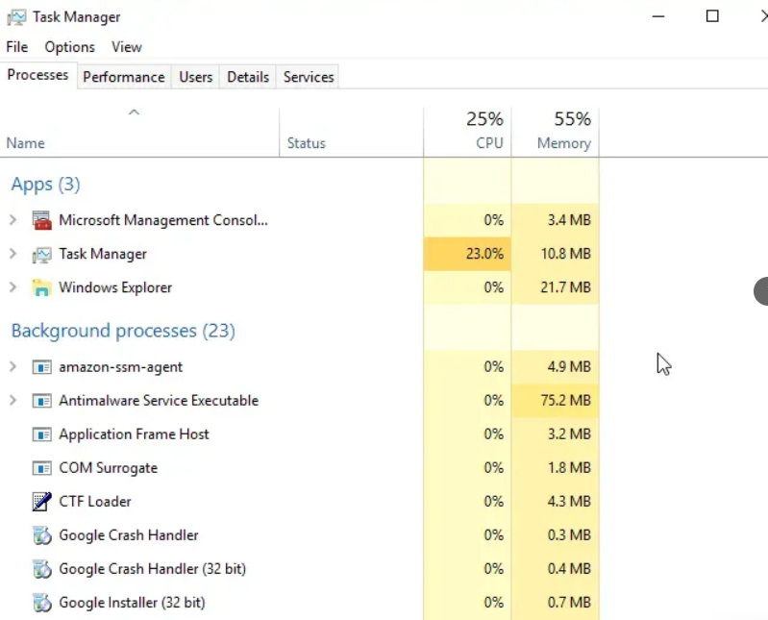

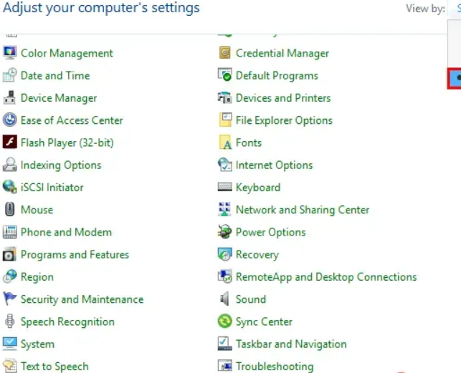

Result:
Thus, the Windows Fundamentals 1 room wAS completed successfully in TryHackMe. Basic to advanced knowledge of the Windows operating system, file systems, security tools, networking, and administrative utilities was gained.

WINDOWS FUNDAMENTALS 2

Aim:
To learn the basic concepts of the Windows operating system, including its interface, file system, security features, system tools, networking, user account management, and advanced Windows administration using the TryHackMe Windows Fundamentals 2.

Procedure:
Windows Fundamentals 2:
- Opened the Windows Fundamentals 2 room in TryHackMe.
- Learned about the Windows file system and NTFS permissions.
- Studied User Account Control (UAC) and administrative privileges.
- Explored Task Manager, System Configuration, and Event Viewer.
- Learned how Windows handles processes and services.
- Completed all practical tasks and submitted answers.

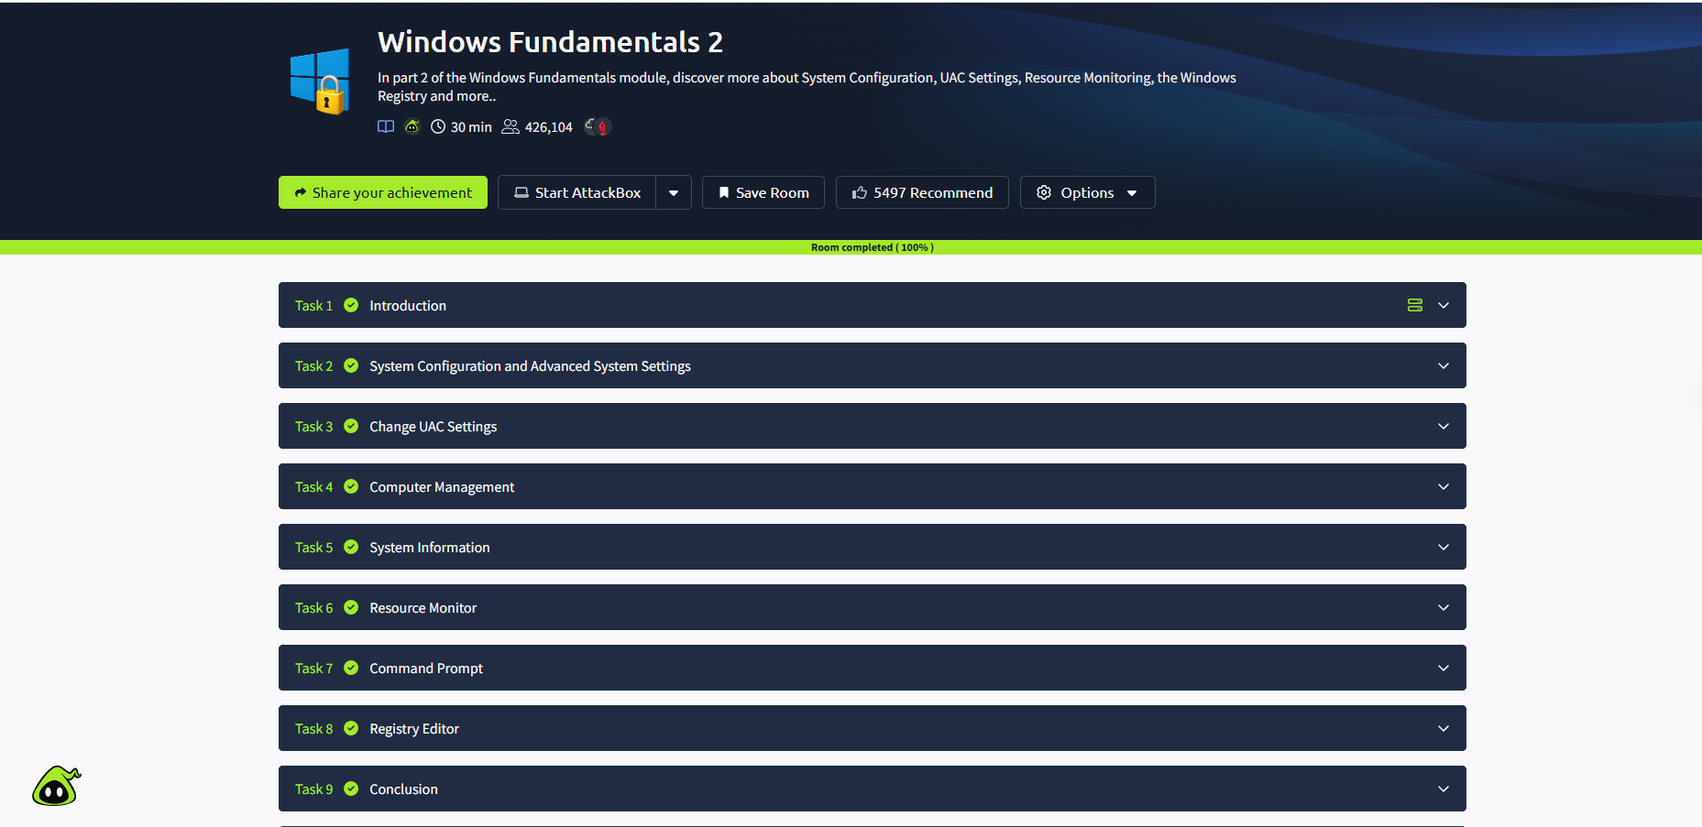

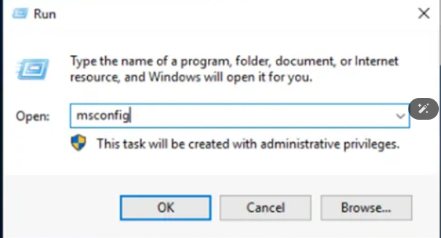

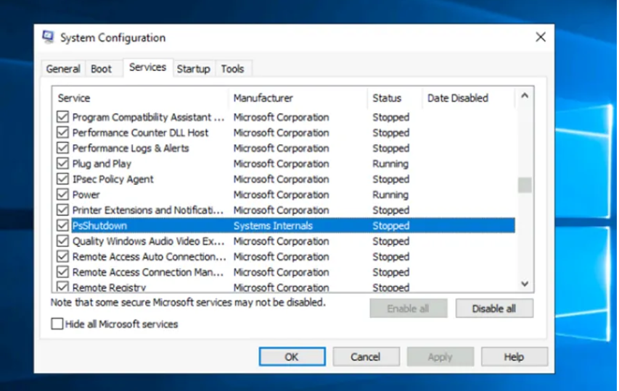
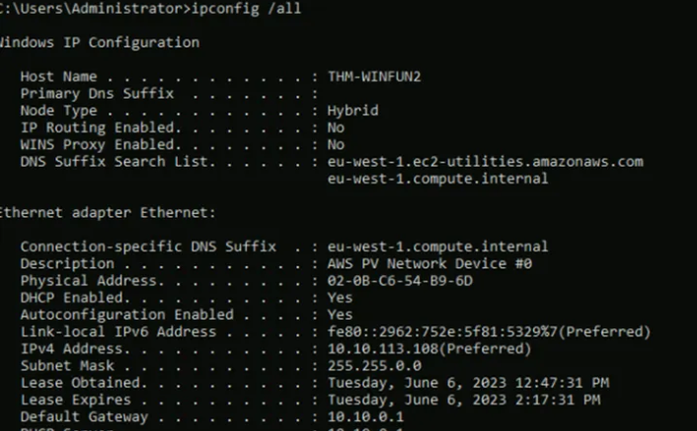

Result:
Thus, the Windows Fundamentals 2 room wAS completed successfully in TryHackMe. Basic to advanced knowledge of the Windows operating system, file systems, security tools, networking, and administrative utilities was gained.

WINDOWS FUNDAMENTALS 3

Aim:
To learn the basic concepts of the Windows operating system, including its interface, file system, security features, system tools, networking, user account management, and advanced Windows administration using the TryHackMe Windows Fundamentals 3.

Procedure:
Windows Fundamentals 3:
- Opened the Windows Fundamentals 3 room.
- Learned about Windows Update and security settings.
- Studied Windows Defender, Firewall, and protection mechanisms.
- Explored networking basics such as IP configuration and command prompt tools.
- Learned about PowerShell basics and system management commands.
- Completed all tasks and answered the room questions successfully.

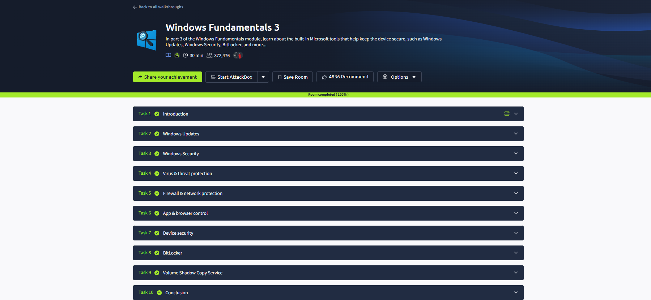

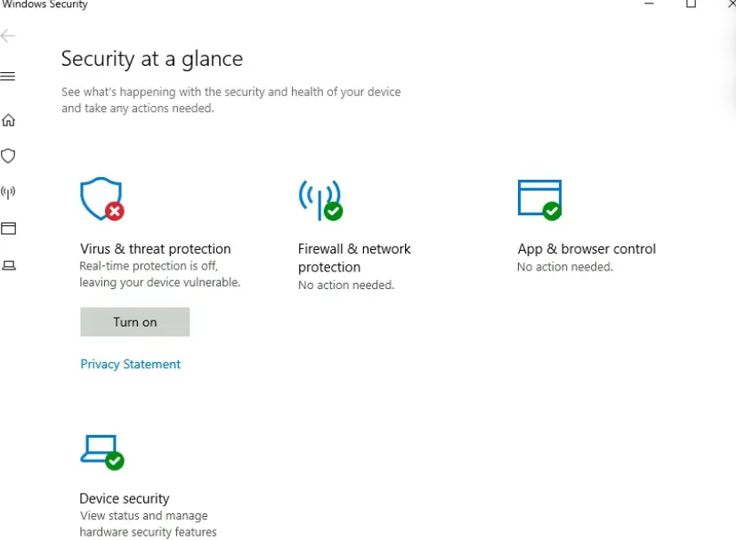
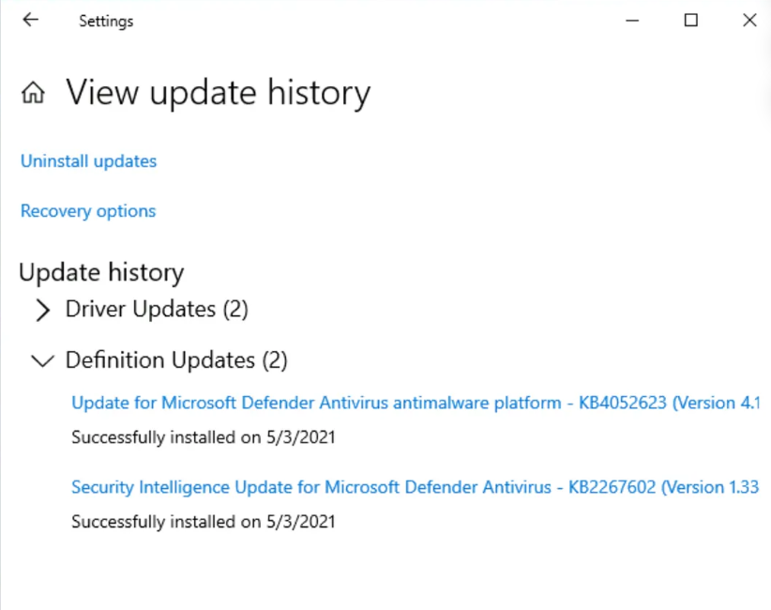
Result:
Thus, the Windows Fundamentals 3 room was completed successfully in TryHackMe. Basic to advanced knowledge of the Windows operating system, file systems, security tools, networking, and administrative utilities was gained.

SECURITY MODELS AND PRINCIPLES
Expt:2
Aim:
To understand the fundamental security models and core security principles used to protect computer systems, networks, and data.

Procedure:
- Logged in to the TryHackMe platform and opened the Security Models and Principles room.
- Learned the basic concepts of Confidentiality, Integrity, and Availability (CIA Triad).
- Studied the principle of Least Privilege, where users are given only the access required.
- Learned about Access Control Models such as:
  - Discretionary Access Control (DAC)
  - Mandatory Access Control (MAC)
  - Role-Based Access Control (RBAC)
- Explored security models such as:
  - Bell-LaPadula Model (focuses on confidentiality)
  - Biba Model (focuses on integrity)
  - Clark-Wilson Model (ensures data integrity)
- Learned authentication methods such as passwords, biometrics, and multi-factor authentication.
- Studied risk management concepts including threats, vulnerabilities, and controls.
- Completed all tasks and answered the room questions successfully.

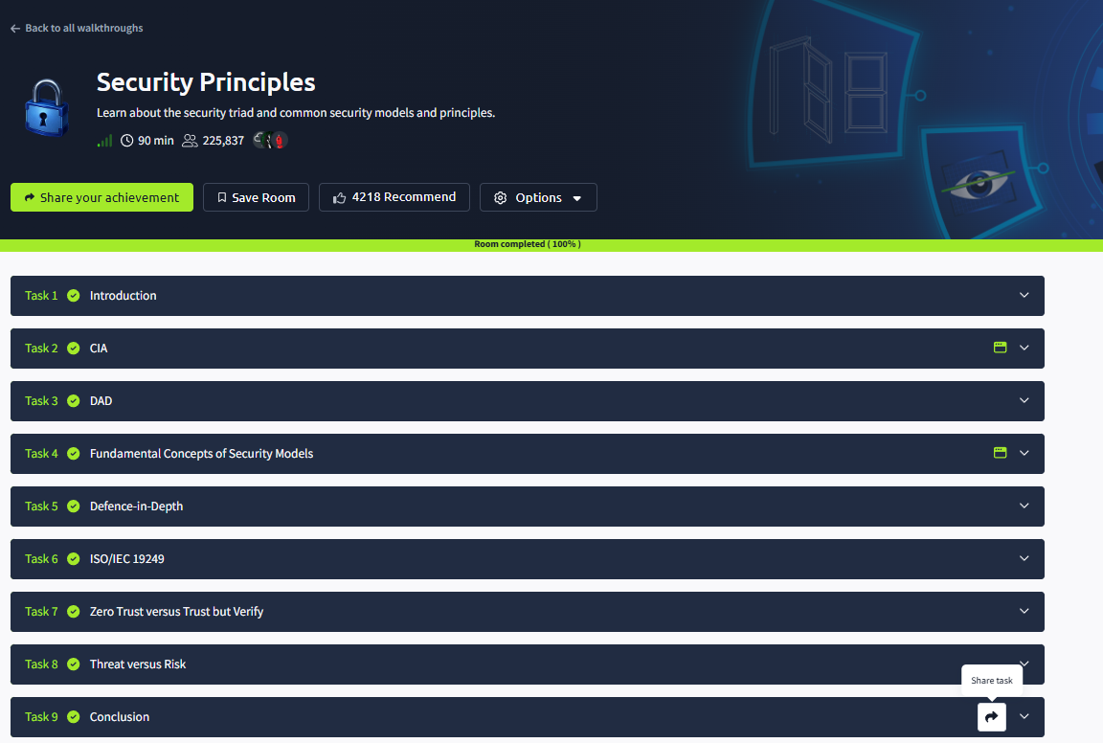

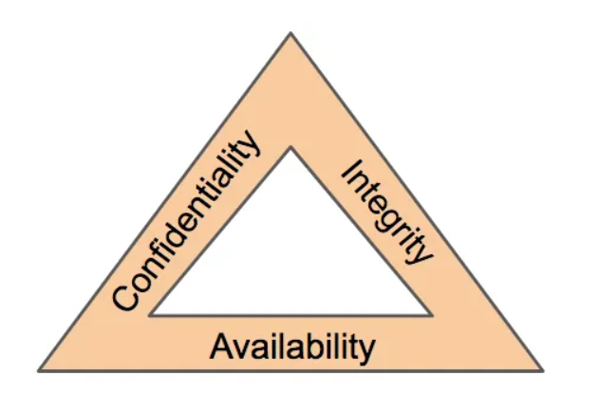

Result:
Thus, the Security Models and Principles room was completed successfully in TryHackMe. Knowledge about security principles, access control methods, and important security models used to secure systems and data was gained successfully.
NETWORK SECURITY ESSENTIALS
Expt:3
Aim:
To understand the basic concepts of network security, common threats, and protection mechanisms used to secure computer networks through the TryHackMe platform.

Procedure:
- Logged in to the TryHackMe platform and opened the Network Security Essentials room.
- Learned the fundamentals of computer networks and communication protocols.
- Studied common network threats such as malware, phishing, spoofing, sniffing, and denial-of-service attacks.
- Learned about network security devices such as firewalls, routers, switches, and Intrusion Detection/Prevention Systems (IDS/IPS).
- Explored secure communication methods using encryption, VPNs, and secure protocols like HTTPS and SSH.
- Learned about authentication methods and access control in networks.
- Studied IP addressing, ports, and network monitoring basics.
- Completed the practical tasks and answered all questions successfully.

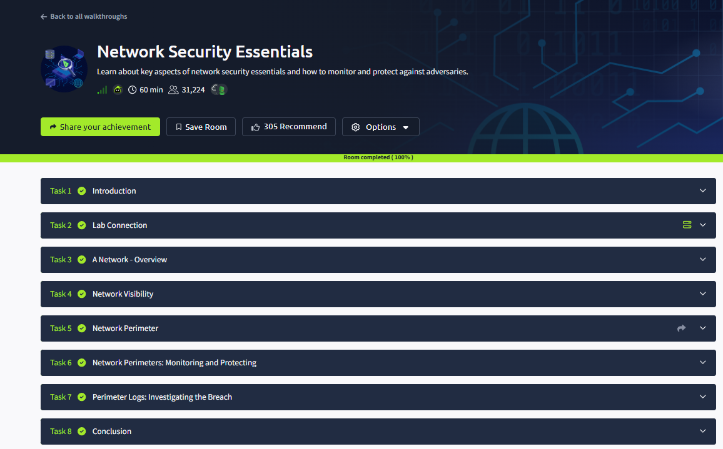
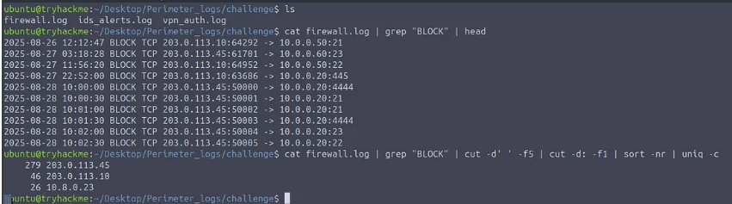

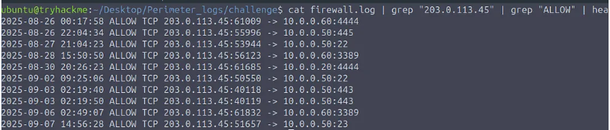

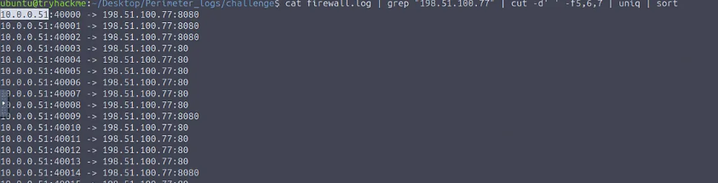
Result:
Thus, the Network Security Essentials room was completed successfully in TryHackMe. Knowledge about network threats, security devices, secure communication methods, and network protection techniques was gained successfully.

ANALYZE THE MALICIOUS NETWORK TRAFFIC USING TRYHACKME
Expt:4
Aim:
To investigate and analyze a compromised Windows system using digital forensics techniques, identify malicious activities, and understand how attackers operate through the TryHackMe Carnage room.

Procedure:
- Logged in to the TryHackMe platform and opened the Carnage room.
- Reviewed the given scenario and collected the provided evidence files.
- Analyzed system logs, suspicious files, and artifacts related to the attack.
- Investigated processes, registry entries, startup locations, and scheduled tasks.
- Identified indicators of compromise such as malicious files, persistence methods, and attacker actions.
- Used forensic tools to inspect evidence and recover important information.
- Traced the attack timeline and determined how the compromise occurred.
- Answered all questions and completed the room successfully.

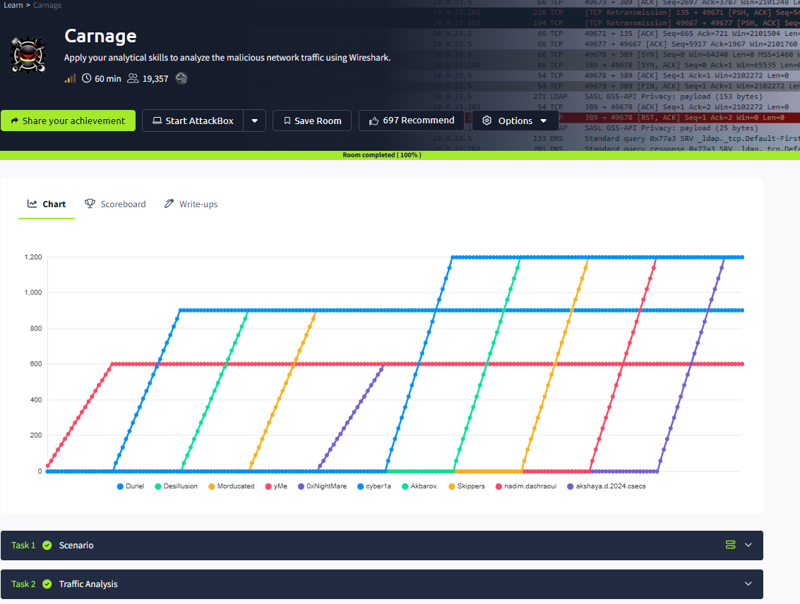
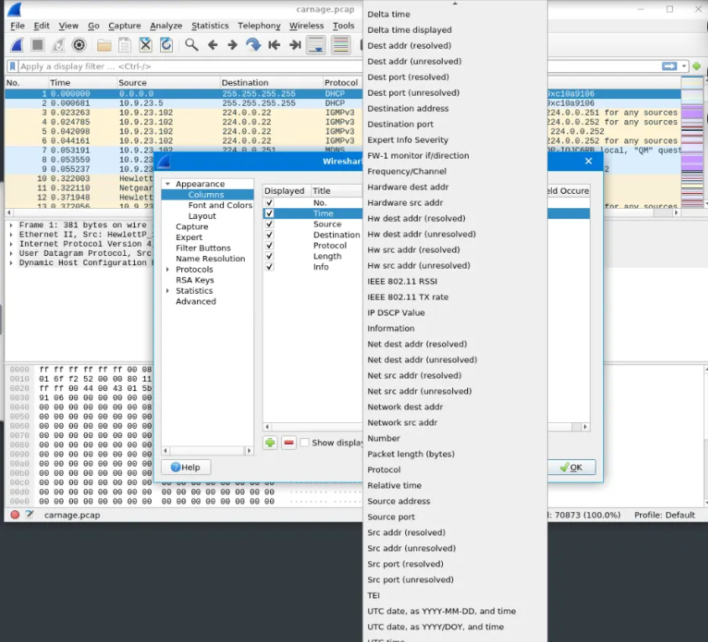

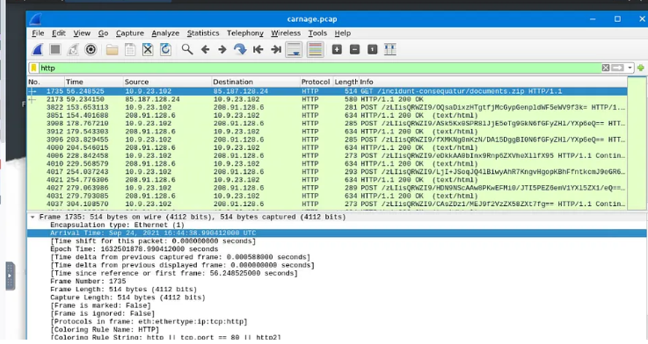
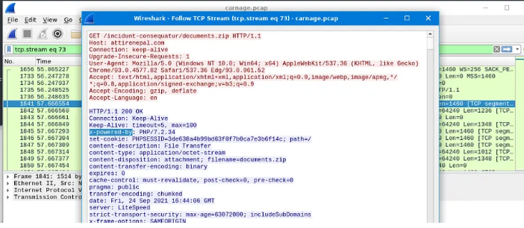

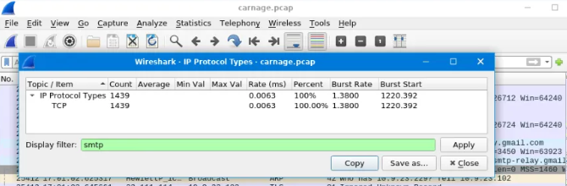

Result:
Thus, the Carnage room was completed successfully in TryHackMe. Knowledge about Windows forensics, malware investigation, persistence mechanisms, and incident analysis was gained successfully.

STACK BASED BUFFER OVERFLOW ATTACK
Expt:5
Aim:
To understand the concept of buffer overflow vulnerabilities in the sudo program, analyze privilege escalation techniques, and learn methods to identify and exploit such security weaknesses through the TryHackMe platform.
Procedure:
- Logged in to the TryHackMe platform and opened the Sudo Buffer Overflow room.
- Reviewed the room scenario and learned about the sudo utility and privilege escalation.
- Studied the concept of buffer overflow, where excess input overwrites memory.
- Analyzed the vulnerable sudo version provided in the lab environment.
- Identified how improper input validation can lead to memory corruption.
- Practiced exploiting the vulnerability to gain elevated privileges in the controlled environment.
- Learned mitigation methods such as patching software, updating sudo versions, and secure coding practices.
- Completed all tasks and answered the room questions successfully.

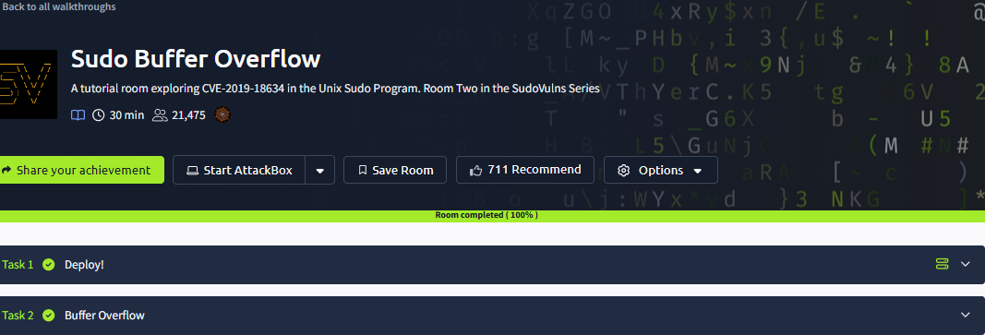
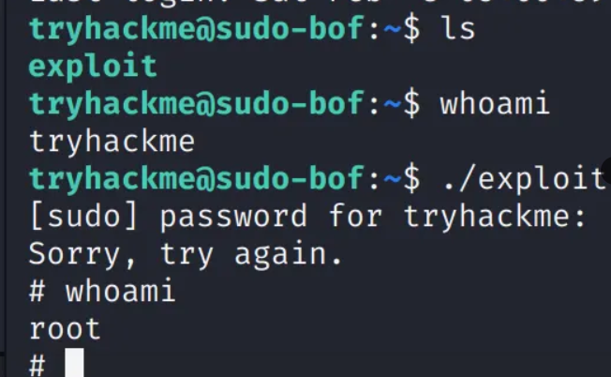

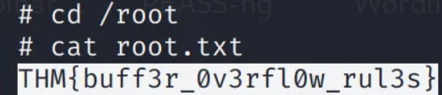

Result:
Thus, the Sudo Buffer Overflow room was completed successfully in TryHackMe. Knowledge about buffer overflow attacks, privilege escalation, sudo vulnerabilities, and security mitigation techniques was gained successfully.

DEMONSTRATE LINUX PRIVILEGE ESCALATION
Expt:6
Aim:
To understand various privilege escalation techniques in Linux systems, identify common misconfigurations, and learn methods used to gain higher privileges through the TryHackMe platform.
Procedure:
- Logged in to the TryHackMe platform and opened the Linux Privilege Escalation room.
- Reviewed the Linux system environment and user permissions.
- Enumerated system information such as kernel version, running services, users, and groups.
- Checked for misconfigured SUID/SGID files, writable files, and insecure permissions.
- Investigated scheduled tasks such as cron jobs for possible exploitation.
- Analyzed sudo privileges using sudo -l to identify allowed commands.
- Explored environment variables, PATH hijacking, and weak service configurations.
- Practiced privilege escalation techniques in the lab environment and completed all tasks successfully.
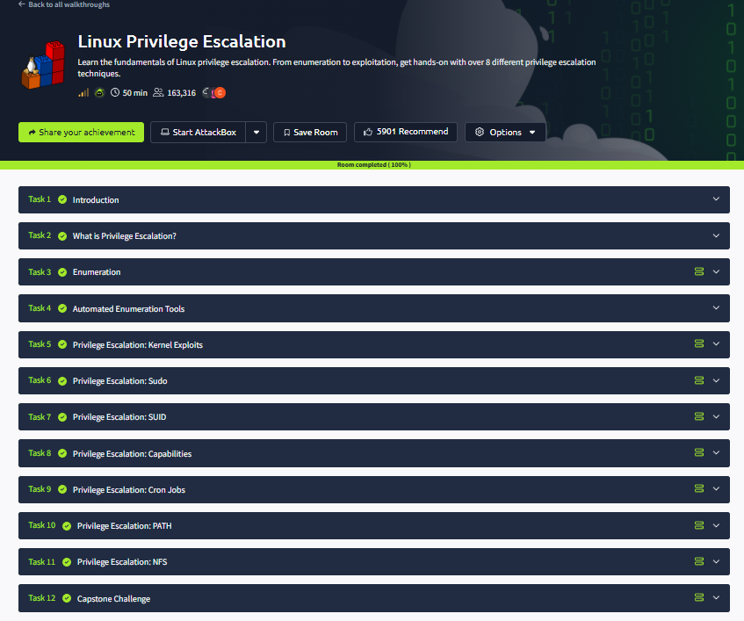

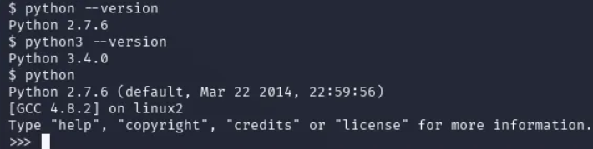

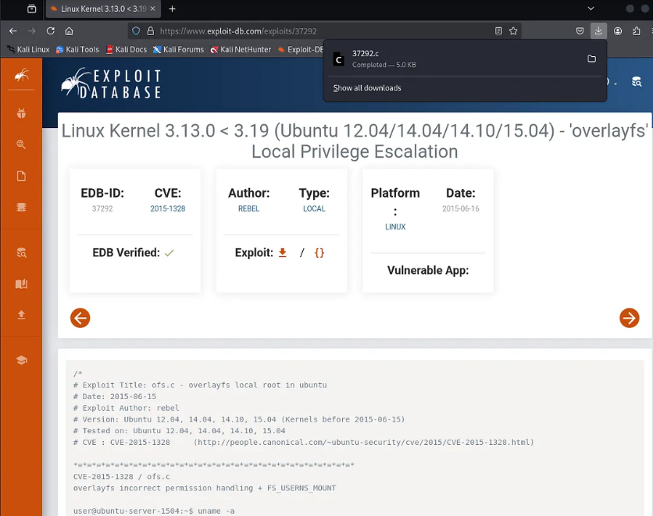
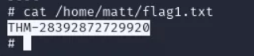

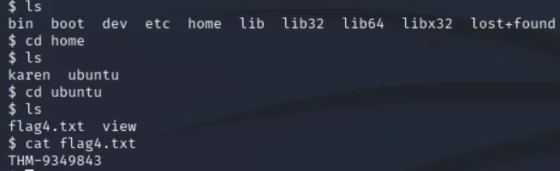

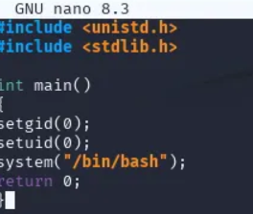
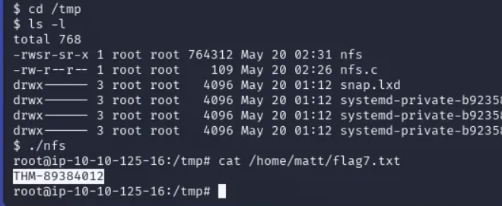
Result:
Thus, the Linux Privilege Escalation room was completed successfully in TryHackMe. Knowledge about Linux permissions, system enumeration, common vulnerabilities, and privilege escalation techniques was gained successfully.

SECURE NETWORK ARCHITECTURE
Expt:7
Aim:
To understand the design of secure network architecture, network segmentation methods, and security controls used to protect organizational networks through the TryHackMe platform.
Procedure:
- Logged in to the TryHackMe platform and opened the Secure Network Architecture room.
- Learned the basic concept of secure network design and layered security.
- Studied network zones such as internal network, DMZ, external network, and guest network.
- Understood the use of firewalls, routers, and switches for traffic control.
- Learned about network segmentation using VLANs and subnetting.
- Explored secure remote access methods such as VPN.
- Studied Intrusion Detection and Prevention Systems (IDS/IPS).
- Learned the importance of access control, monitoring, and regular patching.
- Completed all tasks and answered the room questions successfully.
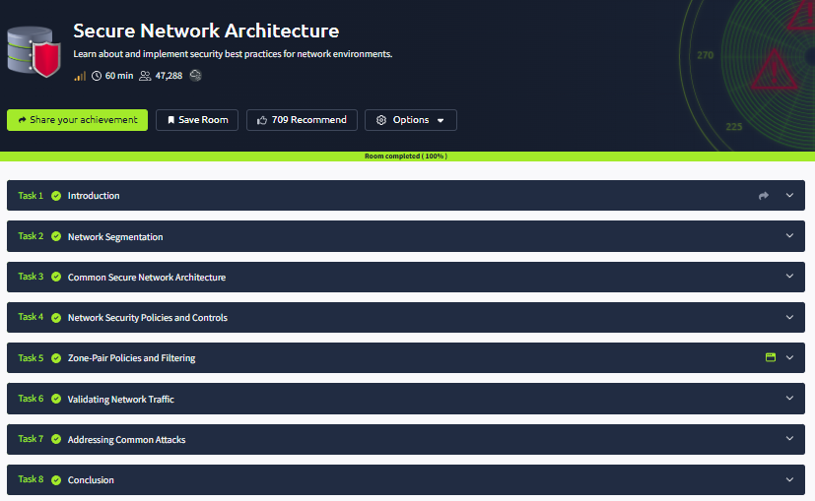

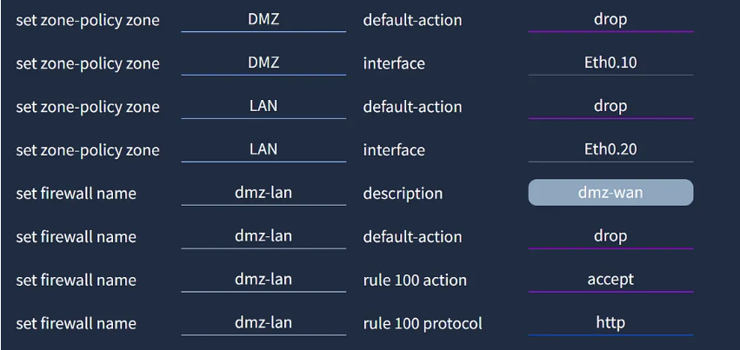

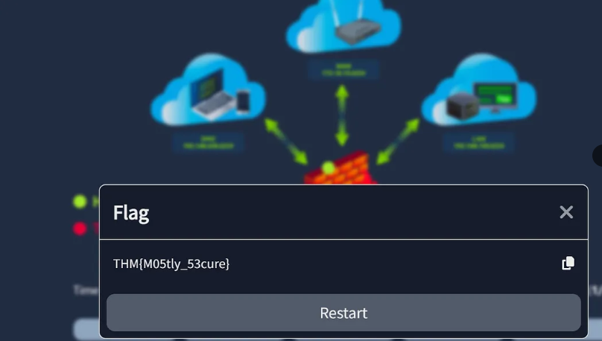

Result:
Thus, the Secure Network Architecture room was completed successfully in TryHackMe. Knowledge about secure network design, segmentation, firewalls, VPNs, and network protection techniques was gained successfully.

PERFORM ROOTKIT DETECTION AND REMOVAL USING RKHUNTER TOOL
Expt:8
Aim:
To understand the structure of the Linux file system, analyze important directories and files, and perform basic forensic analysis through the TryHackMe platform.
Procedure:
- Logged in to the TryHackMe platform and opened the Linux File System Analysis room.
- Learned the hierarchical structure of the Linux file system starting from the root directory /.
- Studied important directories such as /bin, /etc, /home, /var, /tmp, and /usr.
- Analyzed system configuration files, user account files, and log files.
- Used Linux commands such as ls, cd, pwd, cat, find, and grep to examine files and folders.
- Investigated file permissions, ownership, and hidden files.
- Identified suspicious or unusual files during analysis.
- Completed all tasks and answered the room questions successfully.
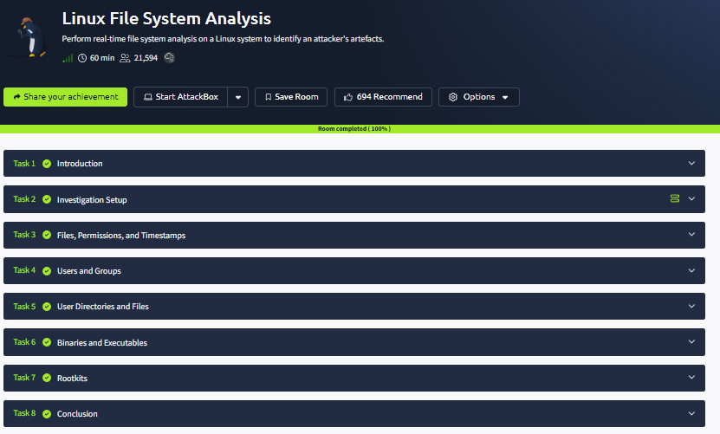
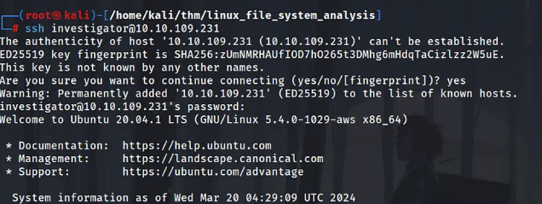

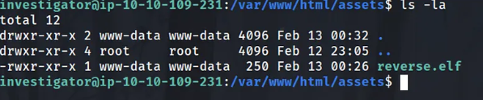
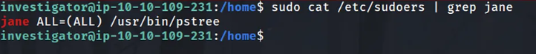
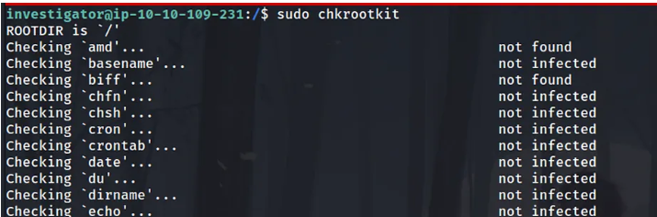

Result:
Thus, the Linux File System Analysis room was completed successfully in TryHackMe. Knowledge about Linux directory structure, file permissions, system files, and basic forensic analysis was gained successfully.

DEPLOYMENT OF HONEYPOTS AND ANALYSIS OF BOTNET ACTIVITIES
Expt:9
Aim:
To understand the concept of honeypots, their types, purpose, and how they are used to detect and study cyber attacks through the TryHackMe platform.
Procedure:
- Logged in to the TryHackMe platform and opened the Introduction to Honeypots room.
- Learned the definition of a honeypot as a decoy system used to attract attackers.
- Studied the purpose of honeypots in detecting unauthorized access and collecting threat intelligence.
- Learned different types of honeypots such as low-interaction and high-interaction honeypots.
- Explored how honeypots monitor attacker behavior and record malicious activities.
- Understood the advantages and limitations of using honeypots in security environments.
- Learned how honeypots help improve incident response and defense strategies.
- Completed all tasks and answered the room questions successfully.
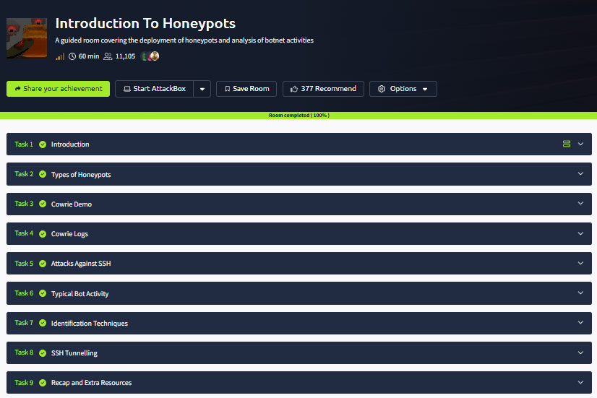

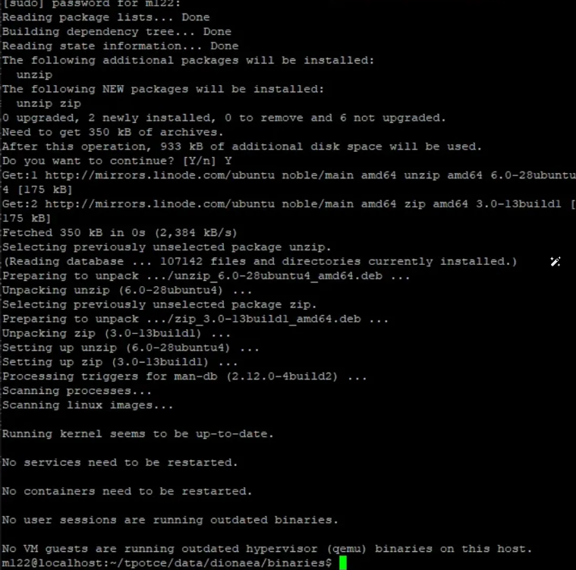
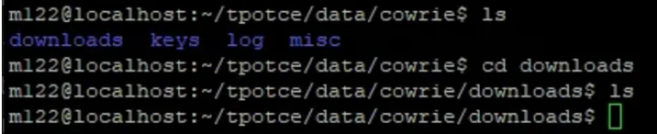

Result:
Thus, the Introduction to Honeypots room was completed successfully in TryHackMe. Knowledge about honeypot concepts, types, uses, and their role in detecting cyber threats was gained successfully.

EXPLORE ANTIVIRUS DETECTION TECHNIQUES
Expt:10
Aim:
To understand the basic concepts of antivirus software, malware detection methods, and the role of antivirus tools in protecting computer systems through the TryHackMe platform.
Procedure:
- Logged in to the TryHackMe platform and opened the Introduction to Antivirus room.
- Learned the purpose of antivirus software in detecting, preventing, and removing malware.
- Studied common types of malware such as viruses, worms, trojans, ransomware, and spyware.
- Learned different detection methods such as signature-based detection, heuristic analysis, and behavior-based detection.
- Explored real-time protection, scheduled scanning, and quarantine features.
- Understood the importance of regular updates for virus definitions and software patches.
- Learned best practices for safe system usage along with antivirus protection.
- Completed all tasks and answered the room questions successfully.

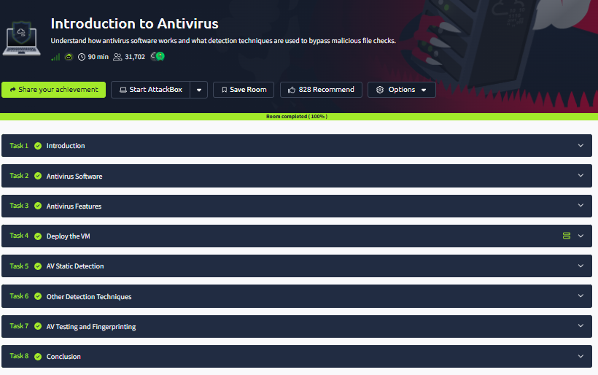

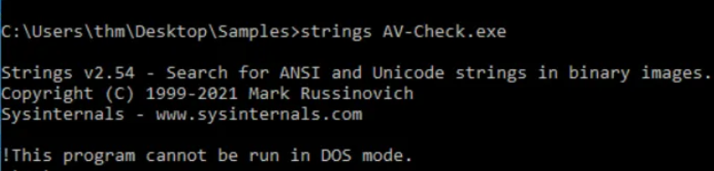

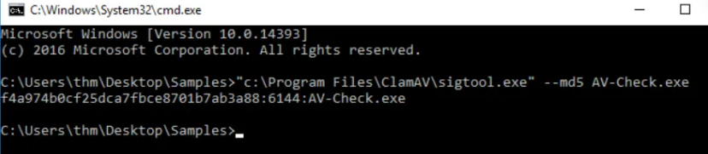

Result:
Thus, the Introduction to Antivirus room was completed successfully in TryHackMe. Knowledge about antivirus concepts, malware detection techniques, and system protection methods was gained successfully.

EXPLORE TOR NETWORK FOR ANONYMOUS COMMUNICATION
Expt:11
Aim:
To understand the concept of the Tor network, its working mechanism, anonymity features, and its uses in secure communication through the TryHackMe platform.
Procedure:
- Logged in to the TryHackMe platform and opened the Tor room.
- Learned the full form of Tor as The Onion Router.
- Studied how Tor routes internet traffic through multiple relay nodes to hide user identity.
- Understood the concept of layered encryption used in onion routing.
- Explored the use of the Tor Browser for anonymous web browsing.
- Learned about hidden services and .onion websites accessible through the Tor network.
- Studied the advantages, limitations, and security considerations of using Tor.
- Completed all tasks and answered the room questions successfully.
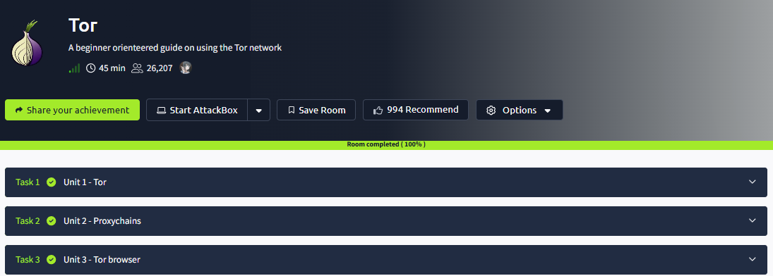

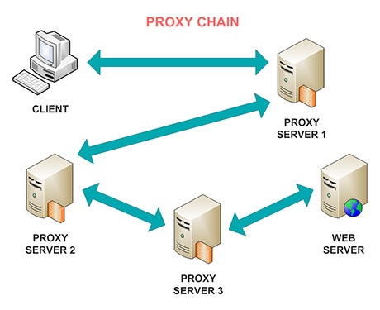

Result:
Thus, the Tor room was completed successfully in TryHackMe. Knowledge about onion routing, anonymous communication, relay nodes, and secure browsing using the Tor network was gained successfully.

DEMONSTRATE CYBER EVASION TECHNIQUES

Expt:12
Aim:
To understand the concept of intrusion detection systems, their types, working methods, and their role in identifying malicious activities in computer networks through the TryHackMe platform.
Procedure:
- Logged in to the TryHackMe platform and opened the Intrusion Detection room.
- Learned the definition of an Intrusion Detection System (IDS) as a tool used to monitor and detect suspicious activities.
- Studied the two main types of IDS:
  - Network-Based IDS (NIDS)
  - Host-Based IDS (HIDS)
- Learned detection methods such as signature-based detection and anomaly-based detection.
- Explored how IDS analyzes logs, traffic, and system behavior.
- Understood alerts, event logging, and incident response processes.
- Learned the differences between IDS and IPS (Intrusion Prevention System).
- Completed all tasks and answered the room questions successfully.
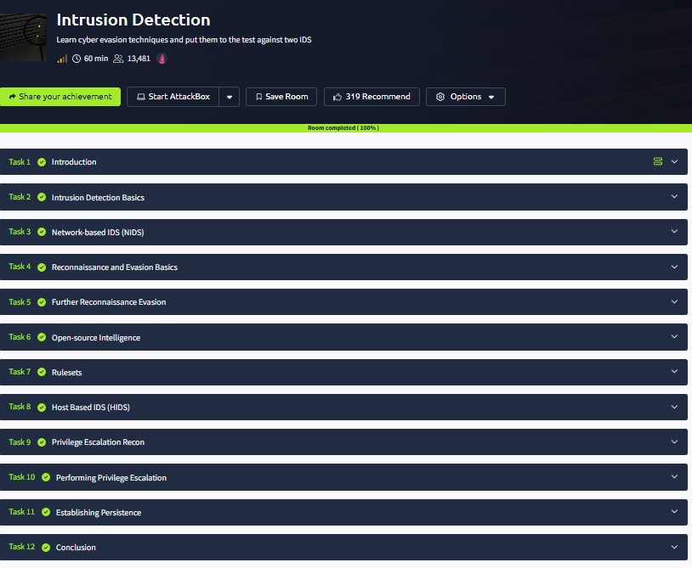
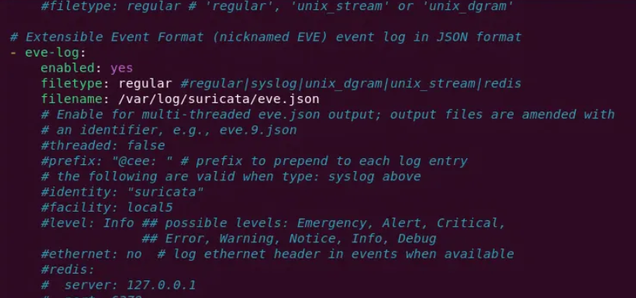
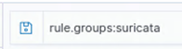

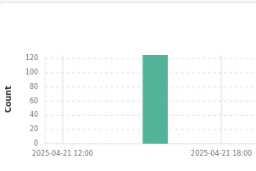

Result:
Thus, the Intrusion Detection room was completed successfully in TryHackMe. Knowledge about IDS types, detection techniques, alerts, and monitoring malicious activities was gained successfully.

THREAT INTELLIGENCE FOR SOC
Expt:13
Aim:
To understand the role of threat intelligence in a Security Operations Center (SOC), identify cyber threats, and improve incident detection and response through the TryHackMe platform.
Procedure:
- Logged in to the TryHackMe platform and opened the Threat Intelligence for SOC room.
- Learned the concept of threat intelligence as information used to identify and prevent cyber threats.
- Studied different types of threat intelligence such as strategic, tactical, operational, and technical intelligence.
- Learned about Indicators of Compromise (IOCs) such as malicious IP addresses, domains, file hashes, and URLs.
- Explored how SOC analysts use threat feeds and intelligence platforms.
- Understood the role of threat intelligence in detection, monitoring, and incident response.
- Learned the importance of correlating alerts with current threat data.
- Completed all tasks and answered the room questions successfully.
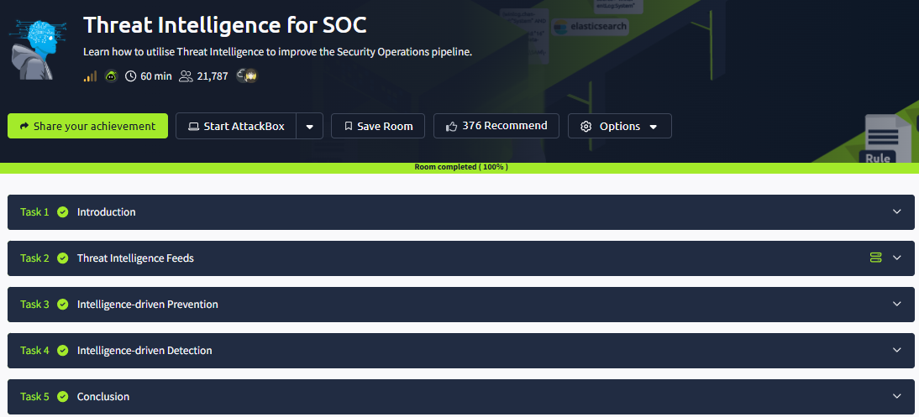

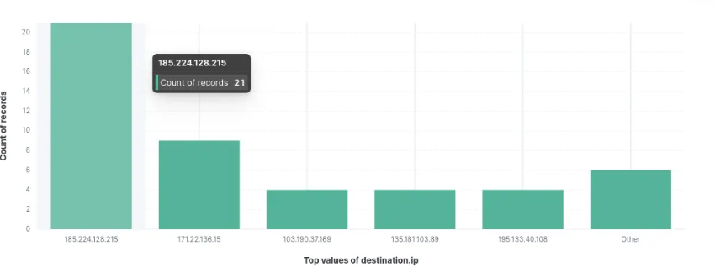
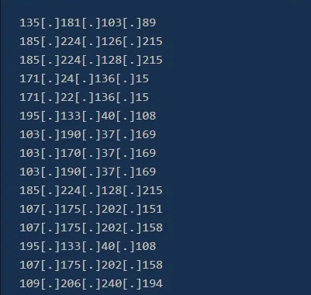
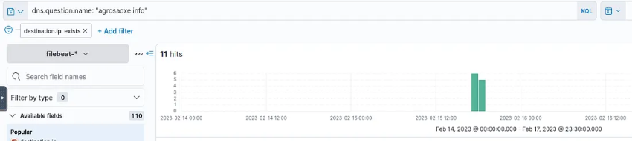
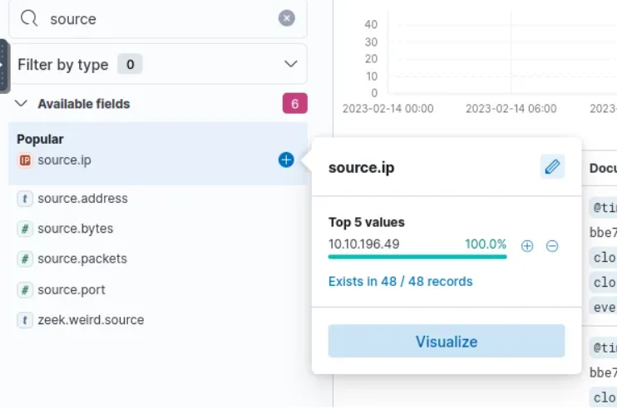

Result:
Thus, the Threat Intelligence for SOC room was completed successfully in TryHackMe. Knowledge about threat intelligence types, IOCs, SOC monitoring, and cyber threat response was gained successfully.

LOG ANALYSIS FOR DETECTION AND RESPONSE
Expt:14
Aim:
To understand the importance of log analysis, learn how to examine system and network logs, and identify suspicious activities through the TryHackMe platform.
Procedure:
- Logged in to the TryHackMe platform and opened the Intro to Log Analysis room.
- Learned the concept of logs as records of system, application, and network events.
- Studied different types of logs such as system logs, security logs, application logs, and firewall logs.
- Learned how logs help in monitoring, troubleshooting, and incident investigation.
- Used tools and commands to search, filter, and analyze log entries.
- Identified suspicious events such as failed logins, unauthorized access, and unusual traffic.
- Understood the importance of timestamps, IP addresses, and event IDs in investigations.
- Completed all tasks and answered the room questions successfully.
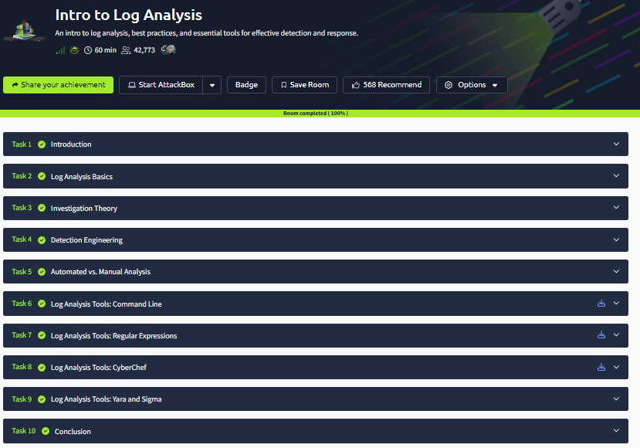
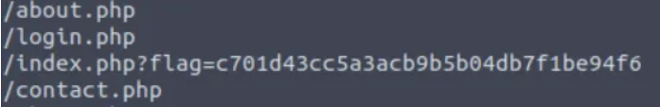
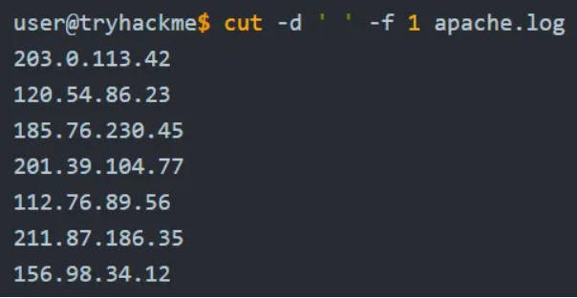
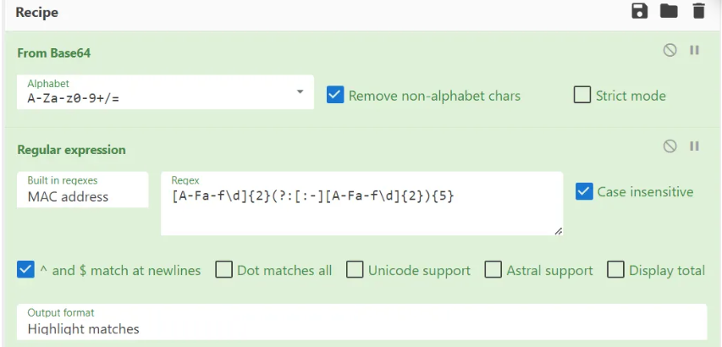

Result:
Thus, the Intro to Log Analysis room was completed successfully in TryHackMe. Knowledge about log sources, event monitoring, suspicious activity detection, and security investigation was gained successfully.

ENDPOINT SECURITY MONITORING
Expt:15
Aim:
To understand the concept of endpoint security monitoring, detect suspicious activities on endpoint devices, and learn methods used to protect systems through the TryHackMe platform.
Procedure:
- Logged in to the TryHackMe platform and opened the Endpoint Security Monitoring room.
- Learned the concept of endpoints such as desktops, laptops, servers, and mobile devices connected to a network.
- Studied the purpose of endpoint security monitoring in detecting threats and unauthorized activities.
- Learned about security tools such as antivirus, EDR (Endpoint Detection and Response), and system monitoring solutions.
- Explored logs, running processes, file changes, and user activities on endpoints.
- Identified suspicious behaviors such as malware execution, privilege escalation, and unusual network connections.
- Understood alert generation, incident response, and remediation methods.
- Completed all tasks and answered the room questions successfully.
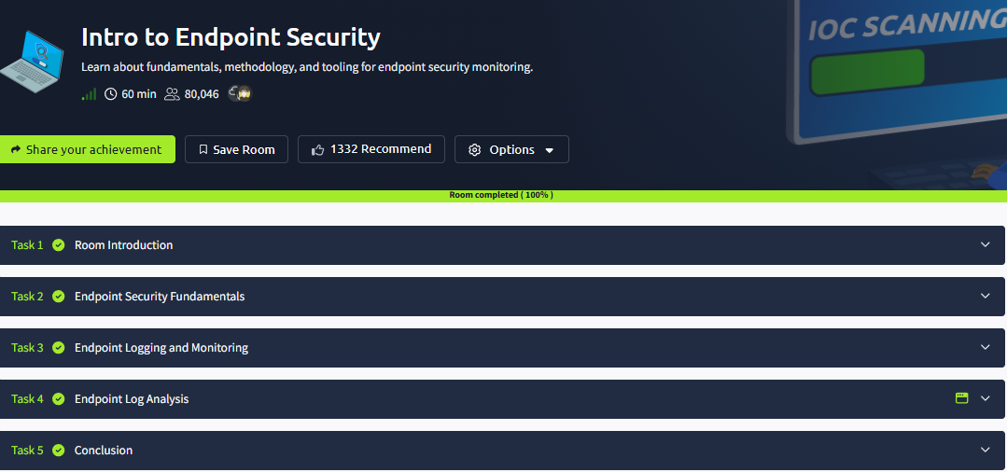

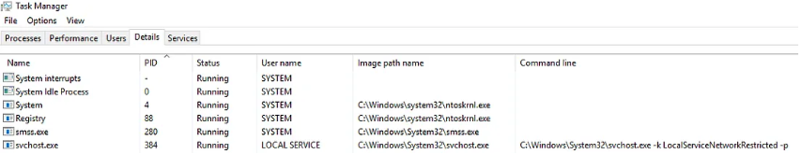
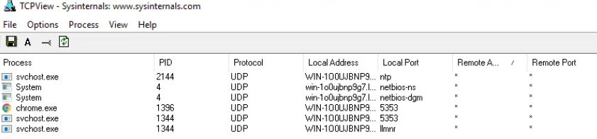
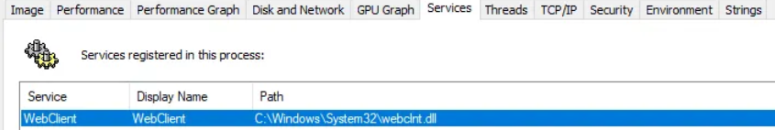
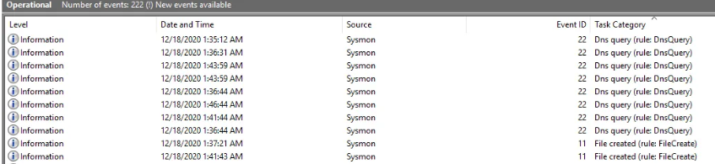
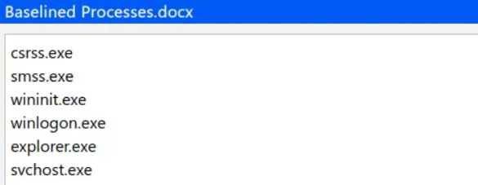
Result:
Thus, the Endpoint Security Monitoring room was completed successfully in TryHackMe. Knowledge about endpoint protection, threat detection, monitoring tools, and incident response was gained successfully.

